- Jumping spiders use a semi hydraulic system in their bodies to jump.
  - Build up of pressure in their cephalothorax which forces fluid into their legs
  - Muscles only used to bend or flex legs, not responsible for the power in jump
  - (also usually attach a silk dragline behind them as a safety tether
    - Could be cool to incorporate

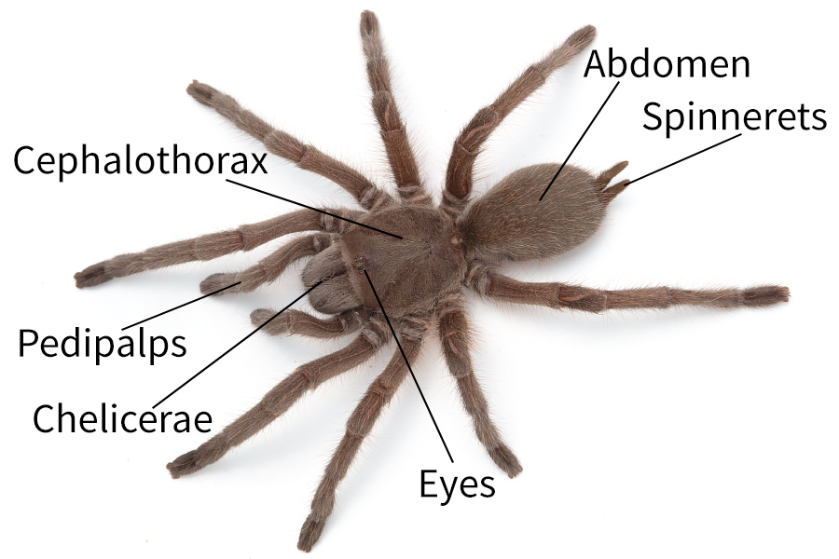

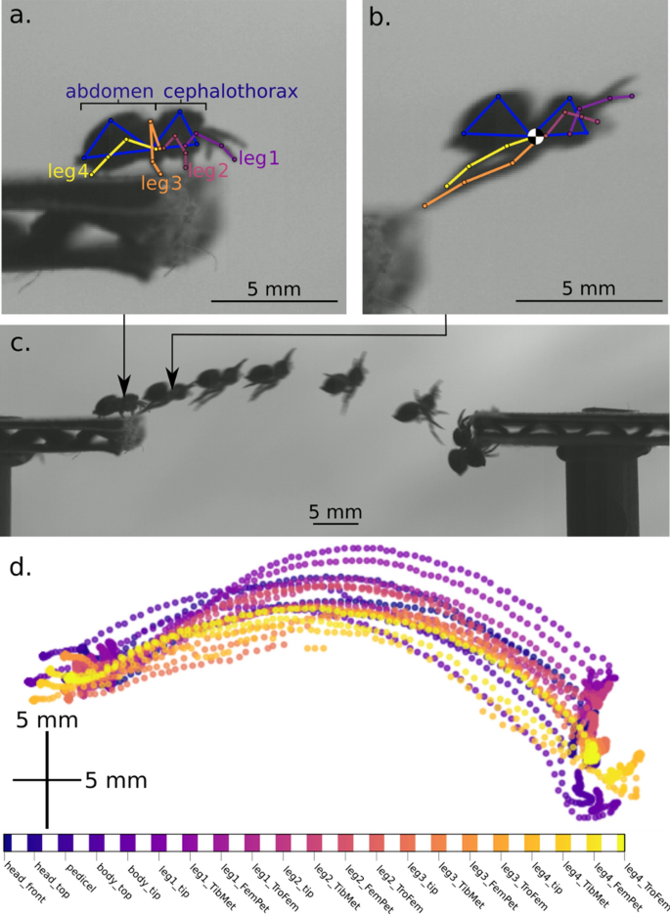
- spiders reached a peak speed of 0.62 ± 0.16 m/s
- Spiders achieved kinetic energies of 2.27 ± 1.23 µJ
- drag forces on spiders were 2.60 × 10–3 ± 2.33 × 10^-3 mN
- Optimal launch angle to cover max distance with air resistance accounted: 30-40 degrees
- Spiders cna usually jump about 6 times their body weight
  - If surfaces are equal height
- https://www.youtube.com/watch?v=xfP-7sbfiWk&t=133s
  - Video on design for hydraulic membrane mechanism for leg
- 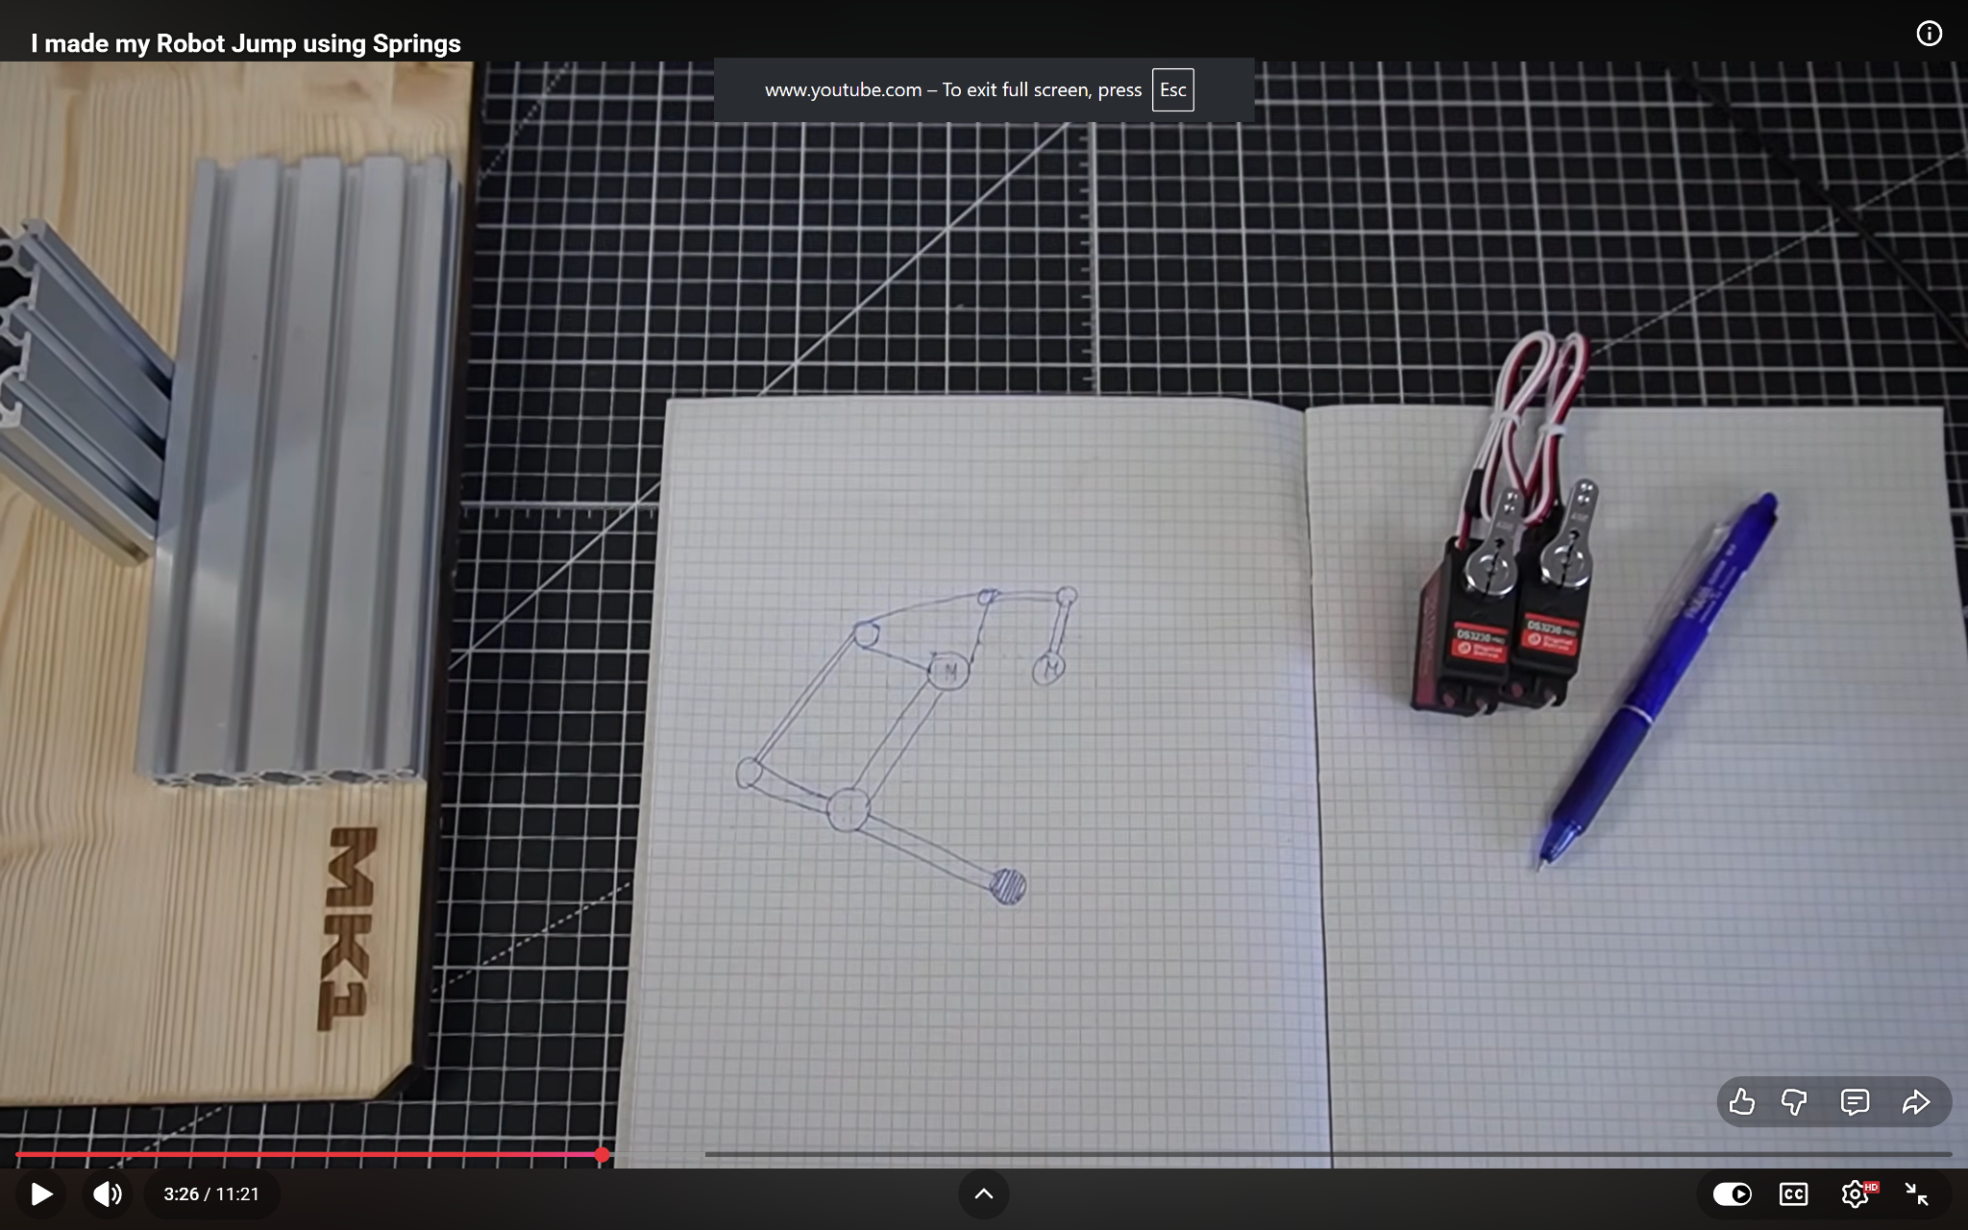
- https://www.youtube.com/watch?v=6z5tpfBbgLo
- 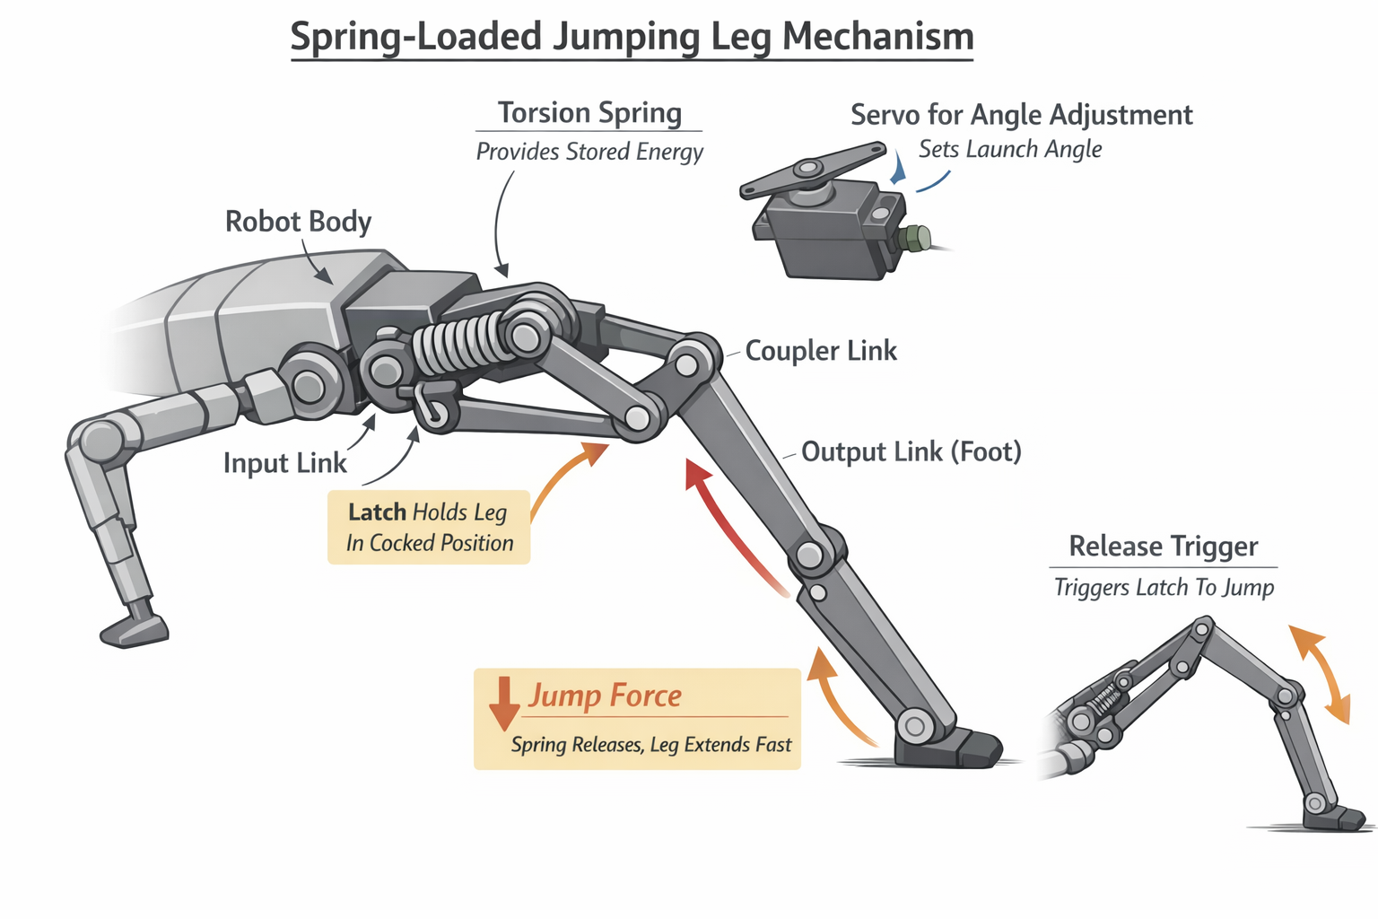
- 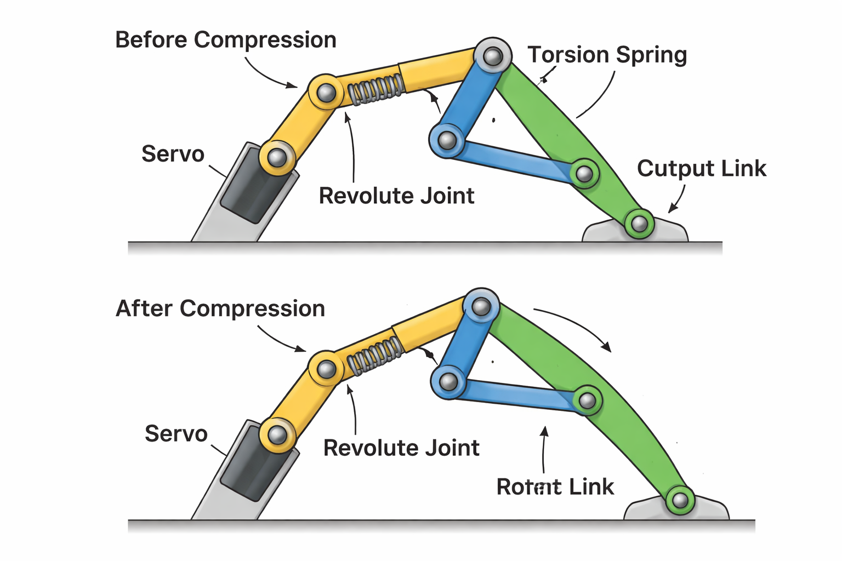

https://www.youtube.com/watch?v=SlGsq0yKnsk

